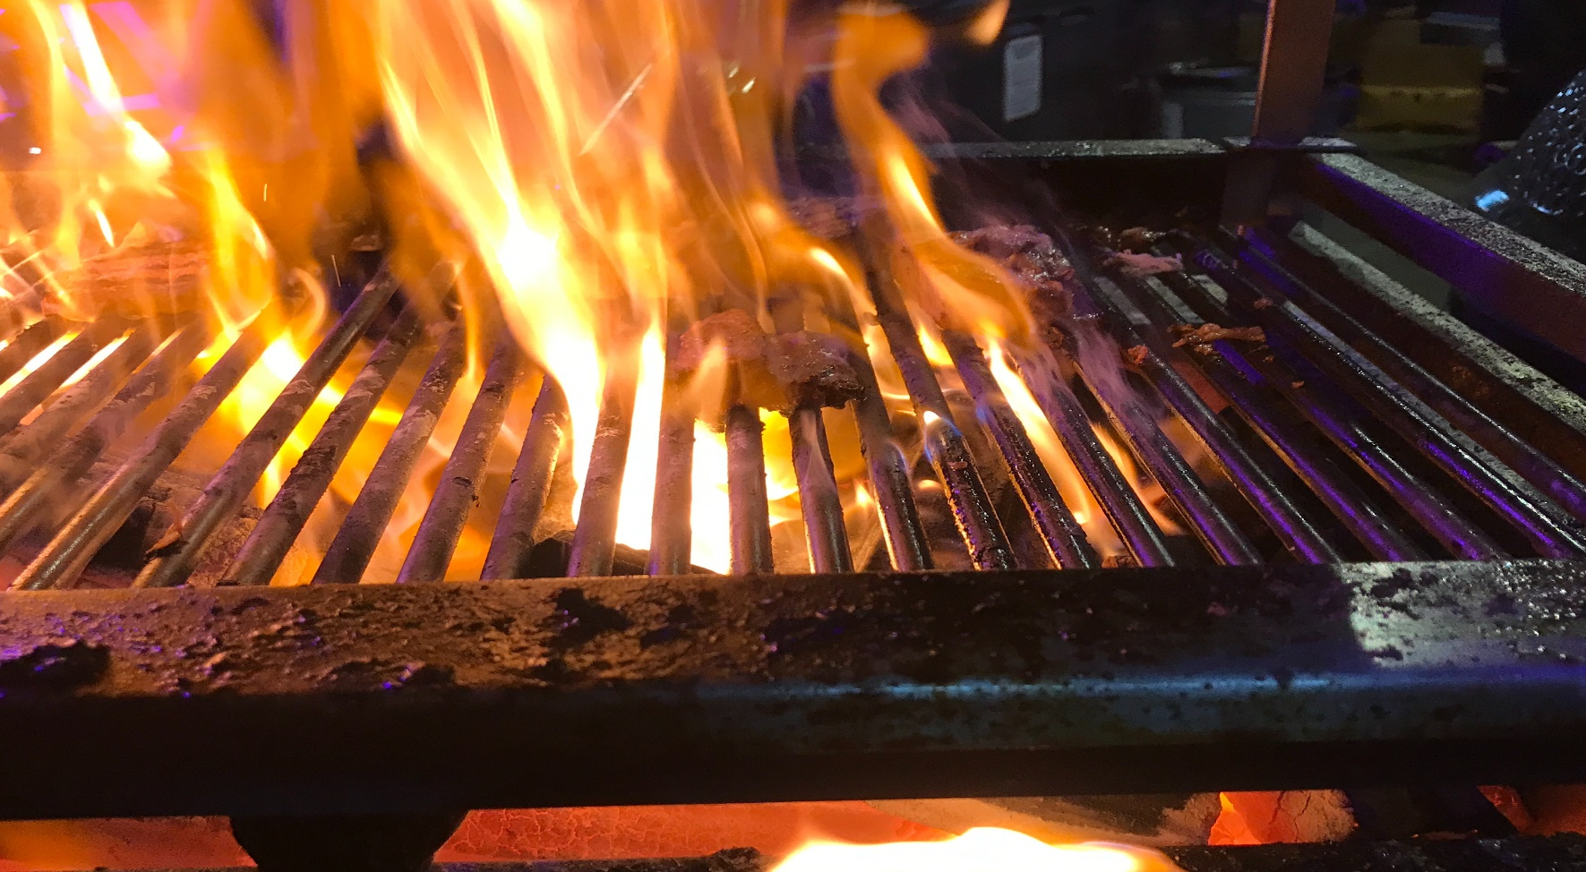

“FIRE IT UP” BBQ CONTEST
Saturday July 5, 2025
Balaton Lions Park—Balaton Fun Fest
THREE CATEGORIES:
**PORK-ribs are provided ($75.00 entry fee) **CHICKEN THIGHS-you provide (25.00 entry fee) **SIDE/APPITIZER-you provide ($25.00 entry fee)
***Need to be entered in all three categories to compete for the Grand & Reserve Prize***
$50.00 nonrefundable deposit is due by June 1st, register by June 1st and get a $25.00 discount for the entry fee and the rest is due the day of the Event
Please make checks payable to Balaton Fun Fest
Mail to:
Fire it Up BBQ Contest, Po Box 184, Balaton MN 56115
More info please contact: Jared Hively 507-829-0612, Ryan Lange 507-829-3691, Rick or Kari Karbo 507-476-5968/507-829-4981

